Mulesoft Training Guide

# Register for Mulesoft Free U course

Go to training.mulesoft.com as shown in screenshot.

Register for Free mulesoft courses highlighted below.

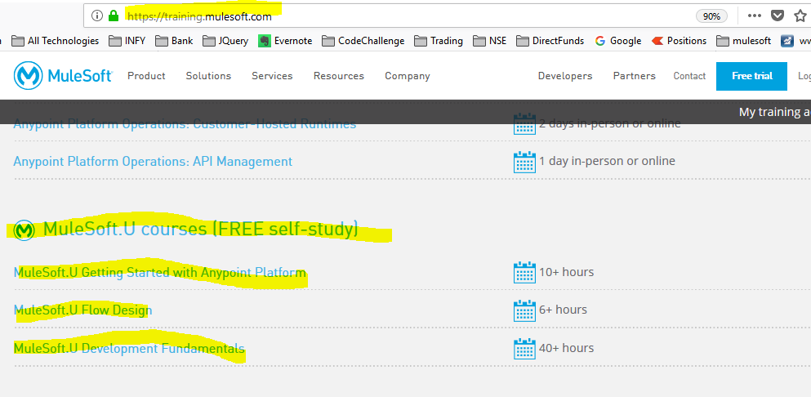

#### Click on first link

#### [MuleSoft.U Getting Started with Anypoint Platform](https://training.mulesoft.com/mulesoftu-getting-started)

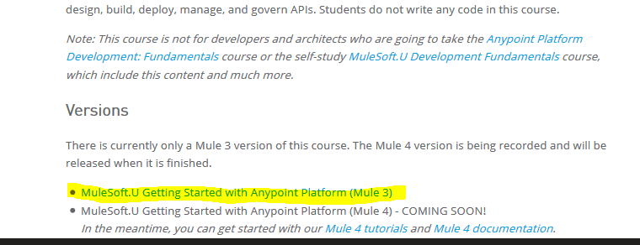

Then click on link getting started with anypoint platform (mule 3) as highlighted

Then click on Register button

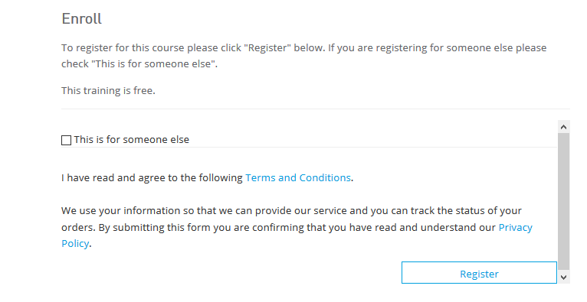

Click on checkout

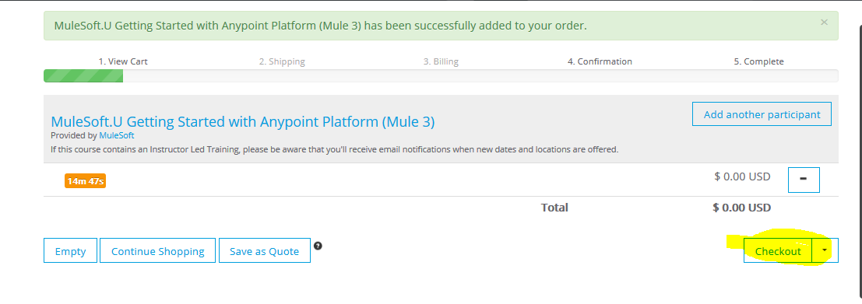

Below page will appear. So you need to register for first time. After that you can directly use Sign in.

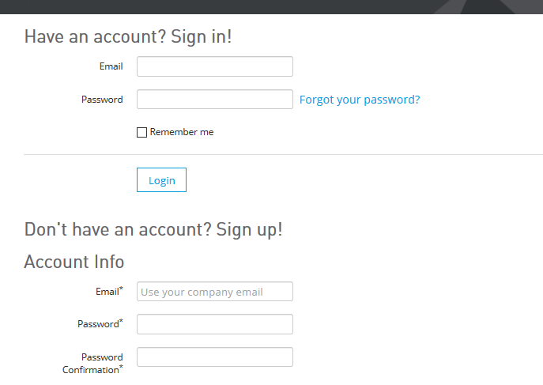

You will get email for video course link.

You can continue shopping and add to cart below 2 courses as well or Repeat the steps as mention.



Additional mulesoft material please explore the website mulesoft.com as highlighted.

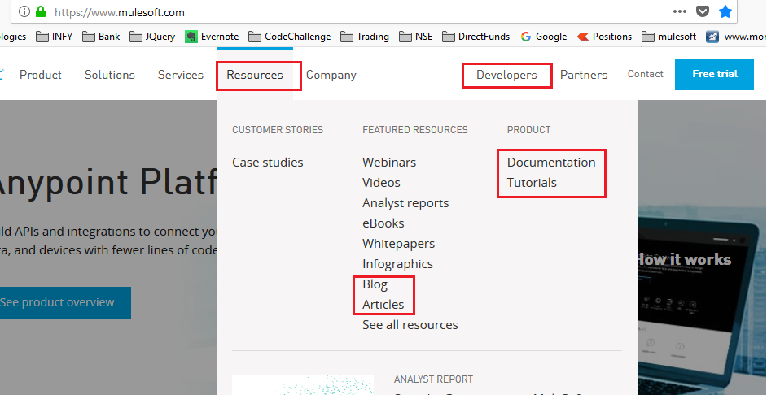

Mulesoft youtube basic videos

https://www.youtube.com/watch?v=0R-hk4xtU1A&list=PL7aRHNGCnFZWEis_pP-lQN2Hhaqkg1wRn